ASSIGNMENT 2

TEAM ID: PNT2022TMID04331

Task 1:Sales By Customer.

Task 2:Sales By Location.

Task 3:Sales By Sales Representative.

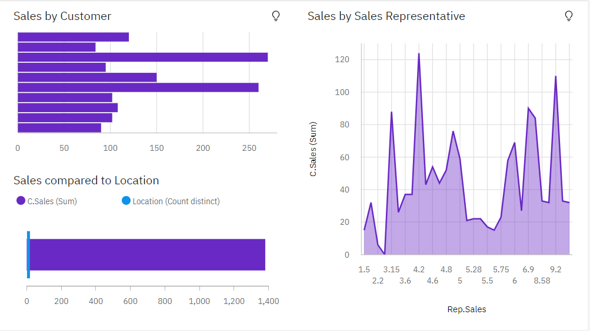

<https://us1.ca.analytics.ibm.com/bi/?perspective=dashboard&pathRef=.my_folders%2FAssignment%2B2&action=view&mode=dashboard&subView=model000001838514a12f_00000000>

Task 4: Received Inventory From Supplier

Task 5: Inventory Stock for Warehouse Locations

Task 6: Sales Trend

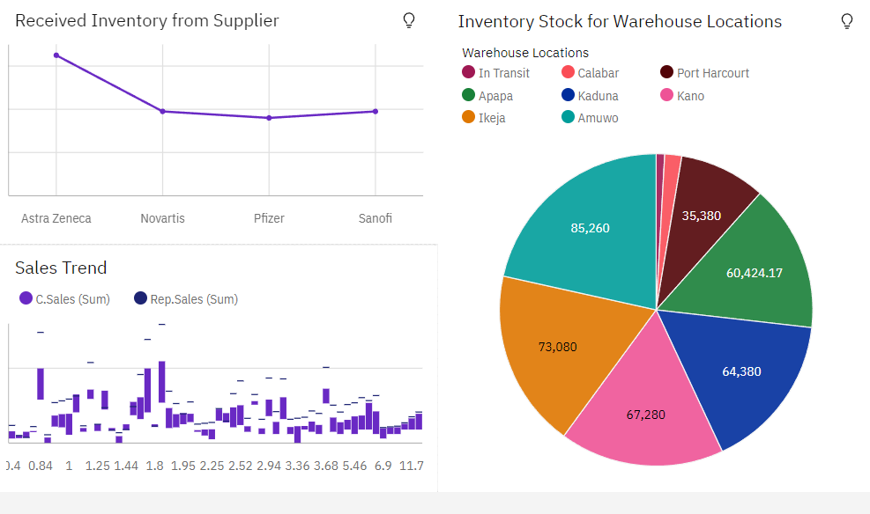

<https://us1.ca.analytics.ibm.com/bi/?perspective=dashboard&pathRef=.my_folders%2FAssignment%2B2&action=view&mode=dashboard&subView=model000001838514a12f_00000000>

Task 7:Monthly Sales

Task 8: Actual and Received Inventory by Month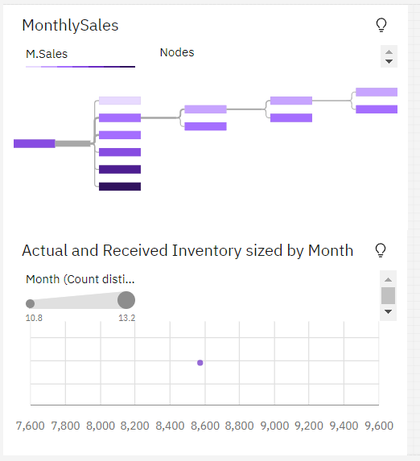

<https://us1.ca.analytics.ibm.com/bi/?perspective=dashboard&pathRef=.my_folders%2FAssignment%2B2&action=view&mode=dashboard&subView=model000001838514a12f_00000000>